Opename: Strategy, Refined by Merit

What Opename Does
Opename transforms your video strategy meeting into a collaborative meritocracy, where participants can:
- Discuss Named Strategies: Each proposed idea is given a unique, trackable name and displayed in real-time.
- Rate Peers by Relevant Expertise: Participants assign dynamic skill ratings to one another, based on relevant experience.
- Vote in Real Time: Strategies are upvoted or deprioritized through live, weighted voting. Vote weights shift dynamically.
- AI-Powered Summary: Transcribes your discussion and auto-generates summaries with influence and dissent maps.
- Live Strategy Refinement: Strategies can be added, edited, or branched—all tracked in a live strategy board.

Controlled Access & Privacy
Only the session initiator registers an email address. This allows:
- Secure download of session outcomes
- Authority to close the session
- Permanent deletion of all records
Other participants join anonymously. We do not store data after the session unless explicitly requested.

What You Get After Each Session
- PDF/Markdown export of:
• Final strategy list with vote-weighted scores
• Summary of key arguments
• Peer influence heatmap
• Optional transcript
- Private download link sent to session initiator
- Option to delete all session data

Pricing Model
Pay Per Session — no subscriptions:
- Small Team (up to 5): $8/session
- Medium Team (up to 12): $18/session
- Large Team (up to 25): $32/session
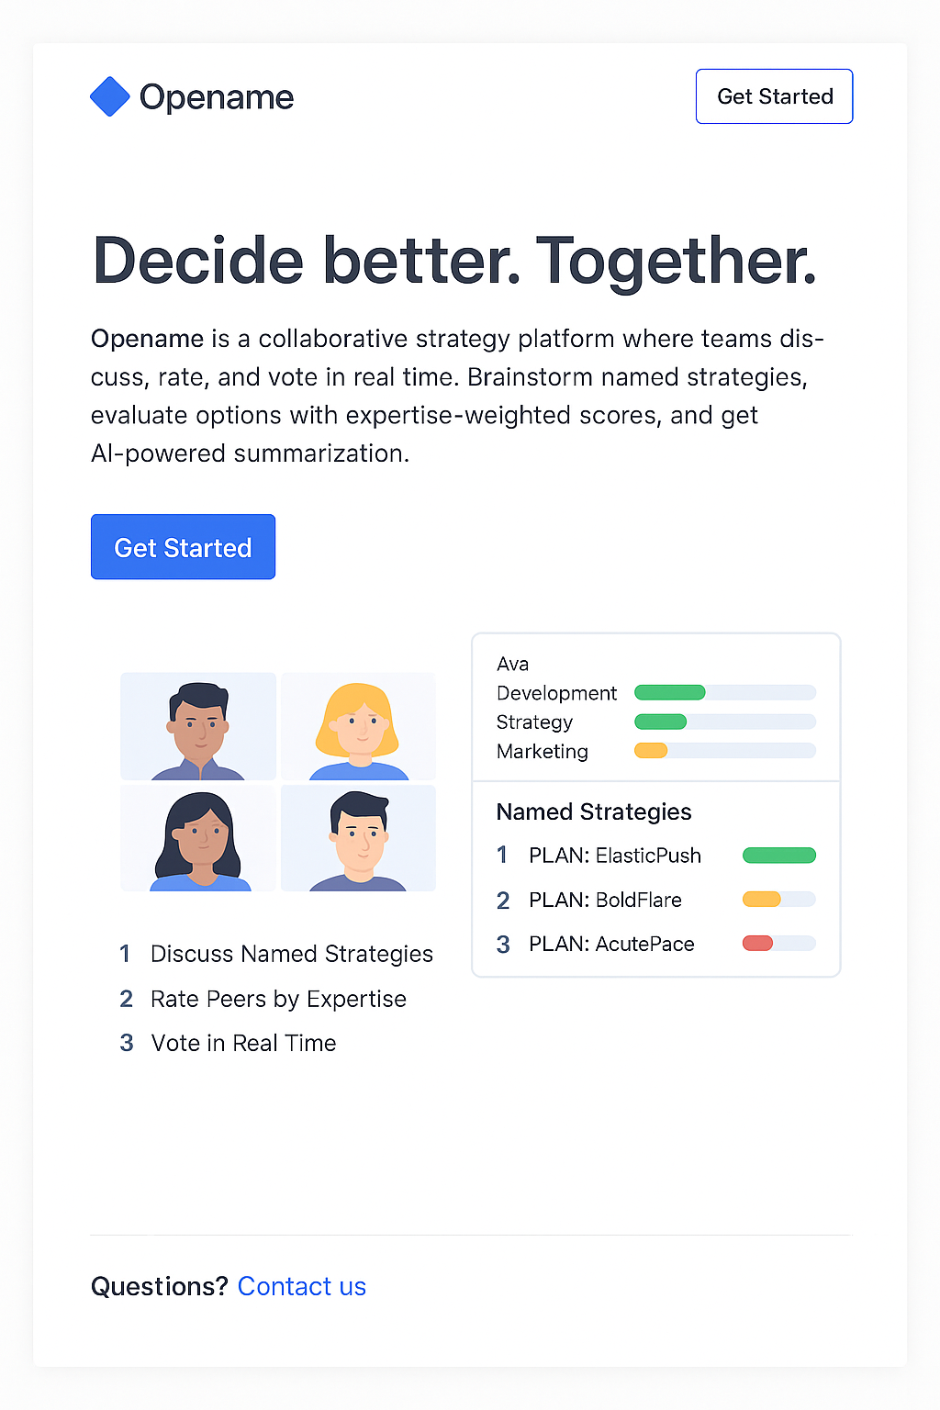
Volume pricing available for frequent users.

Use Cases
- Startup founders deciding between growth models
- Executive teams choosing Q3 focus areas
- Advisory boards narrowing recommendations
- Product managers evaluating roadmap pivots
- Civic groups deliberating protest tactics or messaging

Why Use Opename?
- Stay focused on decisions—not dialogue loops
- Elevate expert insight without silencing new voices
- Document everything automatically
- Delete everything when you’re done
- Pay only when you need it

Tagline
Opename — Decide better. Together.

